Explanation
Combining SkinnedMeshRenderers is very similar to combining regular MeshRenderers, but there are nuances related to animations.
Run the scene. As you can see, the characters’ movement animations are playing.
Now create a MeshCombiner, add the objects, and combine them.
This is because a new combined SkinnedMeshRenderer is created, and the original ones are disabled.
To resolve this issue, select the animators for the characters and change the CullingMode to AlwaysAnimate.

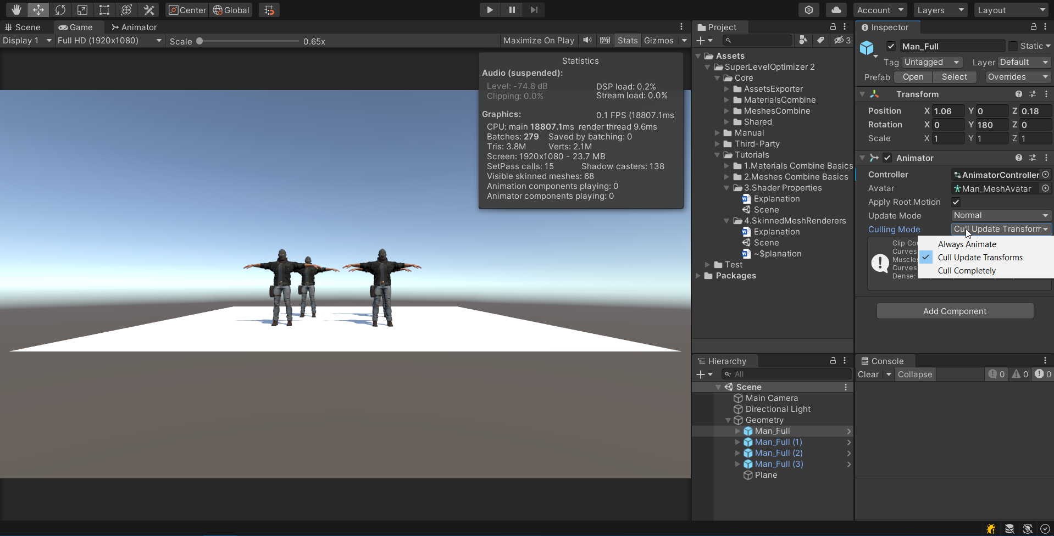

Now, when you run the scene, the animation plays correctly.
Try combining the materials and merging the meshes for this scene.
Note that the texture resolution is 4096x4096. Therefore, to combine the textures, you must set MaxAtlasSize to 8196.

